Instructions to check umpiring allocations

- Log on to www.oxfordshirenetball.co.uk

- Click here:

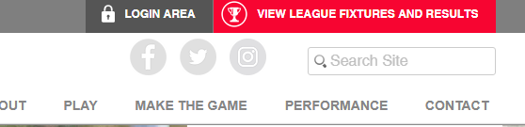

- Change season to OJNL Winter 2019-20 – will automatically take you to U11 Div 1 change to U17 Div 1. Then click on matches once in the OJNL season.

- This screen will then show. Click on Umpires

- This screen will then show. Change this to Match Group: ALL. Then click on Date: and select date you want to look at: then click umpire

- A list of all umpires will appear. Scroll down and find your name – they are in alphabetical order by surname. Click on your name and then click Get Matches

- All your matches for that date will appear. If you right click on the page, it should bring up an option to print if you want a paper copy.

This page will give you the date & time of the game, which teams you are umpiring, the court you are on and who will be your co-umpire. Ump 1 is paid by home team. Ump 2 is paid by Away Team.

All Trainee umpires and Into Officiating umpires will be paid £10 and C, B or A will be paid £15. Please make sure you request payment from the team you are umpiring for before the match starts.

